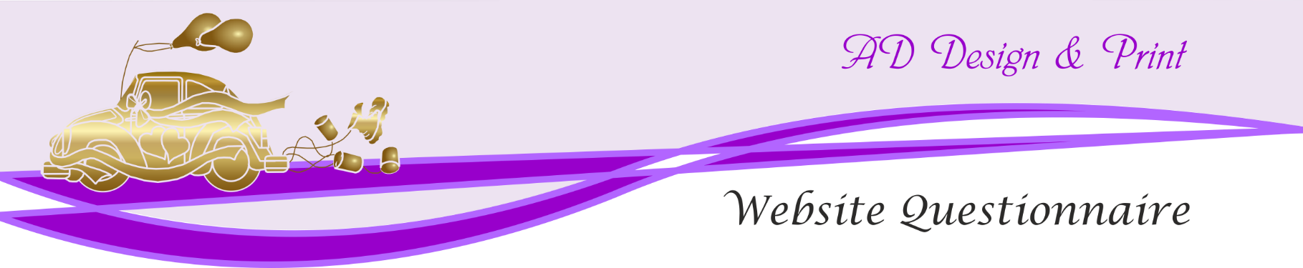

Tell us a bit about your company
Company Name: Enter Company Name
Address: Enter Address
Postal Code: Enter Postcode
Mobile: Enter mobile number
Email: Enter email address

What does your company do?
Tell us briefly what your company does

Let’s get down to business:
Do you have a URL in mind for your business? Tell us the URL you have in mind
Do you need us to buy a domain? Yes ☐ No ☐
What’s your deadline for this project? (dd/mm/yy) Enter a date.
Could you give us a ballpark figure for your available budget for the website project? (£Value)

The next few questions will help us understand exactly what you are after with this site
Tick as many as you need

I want this site because:
I need to build awareness for my brand ☐
I need to offer a contact point to my customers ☐
I need my company to have a better image online ☐
I need to sell my product/service through my site ☐
I need to use it to build customer loyalty ☐
I need somewhere to promote my latest products/services ☐
I have my own reasons Tell us your reasons

My site will be built to target My clients come to me because
Kids & Teens ☐ I offer excellent service ☐
In their 20s ☐ I have the best products ☐
In their 30s ☐ I have the best prices ☐
In their 40s ☐
In their 50s ☐
Senior Citizens ☐

Do you want to expand your target audience in a certain direction?
Tell us your direction

More specific features of your customers

Some words about your company:
Subsidiaries Subsidiaries names
Average number of employees Tell us how many

Someone’s searching the web for your business. What words or phrases will they search for in Google?
Tell us your chosen keywords of phrases, separated with commas

What is it that makes your products/services unique on the market?
Tell us your unique selling point(s)

Do you have any proof that your solutions are better than your competitors?
What backs up your claim(s)

Our new website would need to include:
A basic HTML Site ☐ Social Network Integration ☐
An HTML5/CSS5 website ☐ Intranet system ☐
Responsive design for tablet/mobile ☐ Separate dedicated landing pages ☐
A WordPress based site ☐ A redesign of existing site ☐
Online magazine ☐ Additional requirements ☐
Online forum/blog ☐
Newsletter system ☐

Special features to be included in your new website

We want the following special features to be included in our new website:
Registration form ☐ Registration ☐
Video streaming ☐ An online store/shopping cart ☐
My SQL database ☐ Online payment gateway ☐
Search panel ☐ Blog module ☐
Multicolumn layout ☐ Image gallery ☐
Newsletter/email sign up form ☐ Image slider ☐
Information/request form ☐ Other features List feature(s)
Uploads/downloads ☐
Customer login ☐

Help us out here – Who will provide the following resources?
Us You
Stock photography ☐ ☐
Company photography ☐ ☐
Other artwork/illustrations ☐ ☐
Copywriting text ☐ ☐
Professional logo ☐ ☐
Graphic design ☐ ☐
Metatags/description ☐ ☐
Font licences ☐ ☐

Moving on to the pretty stuff

Moving on to the pretty stuff – Design
Yes No
Does your company have a logo/established image ☐ ☐
& branding guidelines e.g.fonts. colour schemes etc.?

Do you have print materials (such as business cards ☐ ☐
or brochures) that we need to match?

What will happen once we deliver the site?

Yes No
Would you like us to update ☐ ☐
your site or would you like
to be responsible for updates?

How often do you require updates?
Daily ☐
Weekly ☐
Monthly ☐
Quarterly ☐
Other ☐ Tell us how often

Is there anything else you would like to tell us?
Tell us anything we have missed

